Firas Aboushamalah

250 920 750

CS 2214 Assignment 4

Marc Moreno

Problem 1: Counting Tree Leaves

Proof by structural induction:

**Basis case**: Assume that *S(T)* = *l(T)*, number of leaves of a full binary tree *T*, is one more than *i(T),* the number of internal vertices of *T*.

*l(T)* = *i(T)* + 1

The base case is true that, a full binary tree *T* with only one root *r* has exactly one leaf and no internal vertices. Therefore,

*L(T)* = 0 + 1 = 1. This holds for the basis case as the tree has exactly one more leaf than internal vertices. Therefore, *S(T)* is true.

**Recursive Step:**

By the definition,

*L(T1 · T2)*

*= l(T1) + l(T2)*

= *(i(T1)* + 1) + (*i(T2)* + 1)

= *i(T1 · T2)* + 1.

Therefore, the definition holds and *S(T)* holds as well.

Problem 2: Summation

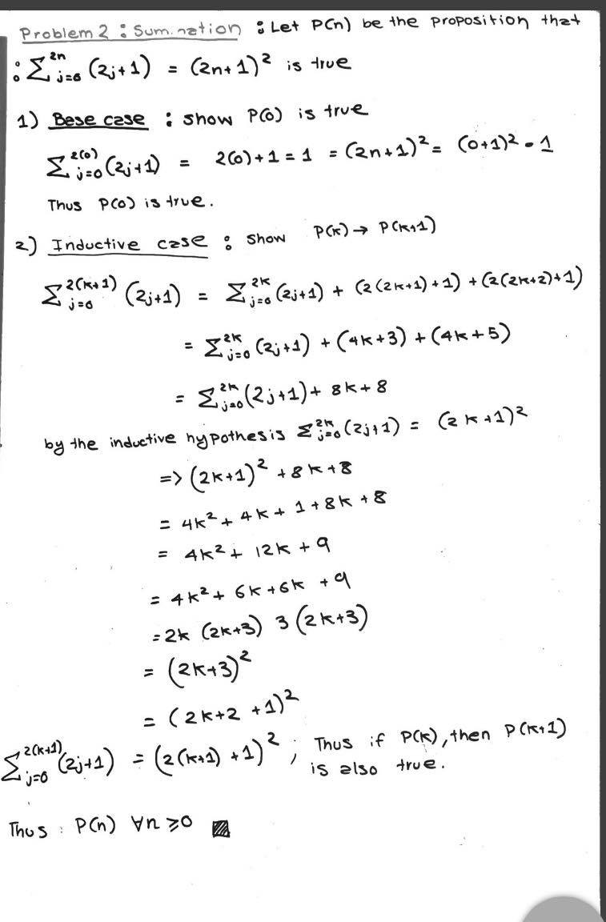

Problem 3: Counting Binary Strings

1. Bit string with length 15 bits. Begin with 00 means there are 2 bits excluded from the 15, so 15 – 2 = 13. 213 = **8192**.
2. Bit string with length 15 bits. Begin with 00 AND end with 11. Therefore 4 bits are removed from the length so 15 – 4 = 11. Therefore 211 = **2048**.
3. Bit string with length 15 bits. We know that to begin with 00, there are 8192 different strings. To end with 10, there are 215-2 permutations which is also 8192. Bits with 00 AND 10 are 2048. Therefore by the subtraction rule, the total of strings that make up “begin with 00 or end with 10” are 8192 + 8192 – 2048 = **14336**.
4. To have exactly ten 1’s, it is C(15, 10). This means (15! / 10! * (5!)) = **3003** different combinations.
5. **None (0 combinations)** as the combination C(6, 10) cannot occur (logically speaking, a string of bit length 15 cannot have 10 values that are not adjacent to each other).

Problem 4: Counting Permutations

1. One position is used while the remainder are able to be shuffled. Therefore, it is 7! = **5040.**
2. A _ _ _ _ _ _ _ or _ A _ _ _ _ _ _, therefore it is 7! + 7! By the sum rule which is **10080**.
3. _ _ _ _ _ _ A E or _ _ _ _ _ _ E A, therefore it is 6! + 6! By the sum rule which is **1440**.
4. D _ _ _ _ _ _ _ or _ _ _ _ _ _ _ D = 10080.This will be subtracted by total summations which is 8! = 8! – 10080 = **30240**.
5. Like above, we have total permutations which is 8! = 40320. Now, we subtract by the permutations of A E together and E A together which is 6! + 6! = 1440. Therefore we have 40320 – 1440 = **38880**.